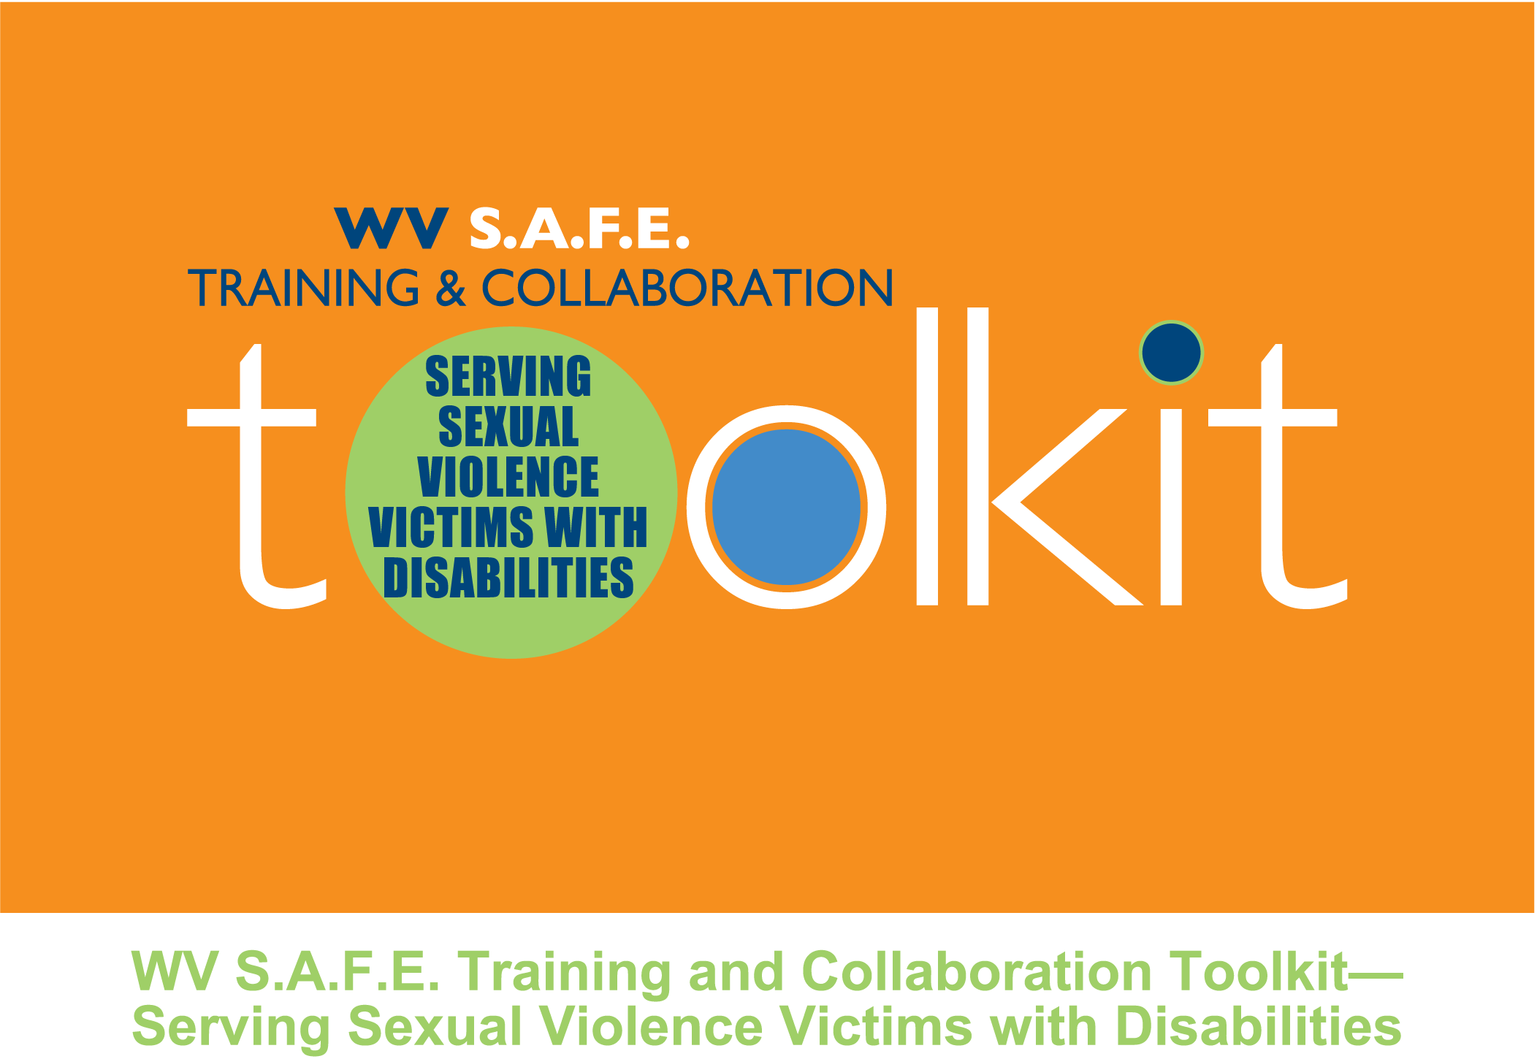
.
A project of the

West Virginia Sexual Assault Free Environment
(WV S.A.F.E.) Partnership

WV S.A.F.E. Partners:
West Virginia Foundation for Rape Information and Services (WVFRIS)
West Virginia Department of Health and Human Resources (WVDHHR)
Northern West Virginia Center for Independent Living (NWVCIL)

Fall 2010

Funding was provided by Grant No. 2006-FW-AX-K001 awarded by the Office on Violence Against Women, U.S. Department of Justice. The opinions, findings, conclusions and recommendations expressed in this toolkit are those of the authors and do not necessarily reflect the views of the U.S. Department of Justice, Office on Violence Against Women.

Project partners welcome the non-commercial use of this toolkit to increase knowledge about serving sexual violence victims with disabilities in any community, and adaptation for use in other states and communities as needed, without the need for permission. We do request that any material used from this toolkit be credited to the West Virginia Sexual Assault Free Environment (WV S.A.F.E.) project, a partnership of the West Virginia Foundation for Rape Information and Services, the Northern West Virginia Center for Independent Living and the West Virginia Department of Health and Human Resources (2010). Questions about the project should be directed to
the West Virginia Foundation for Rape Information and Services at www.fris.org.
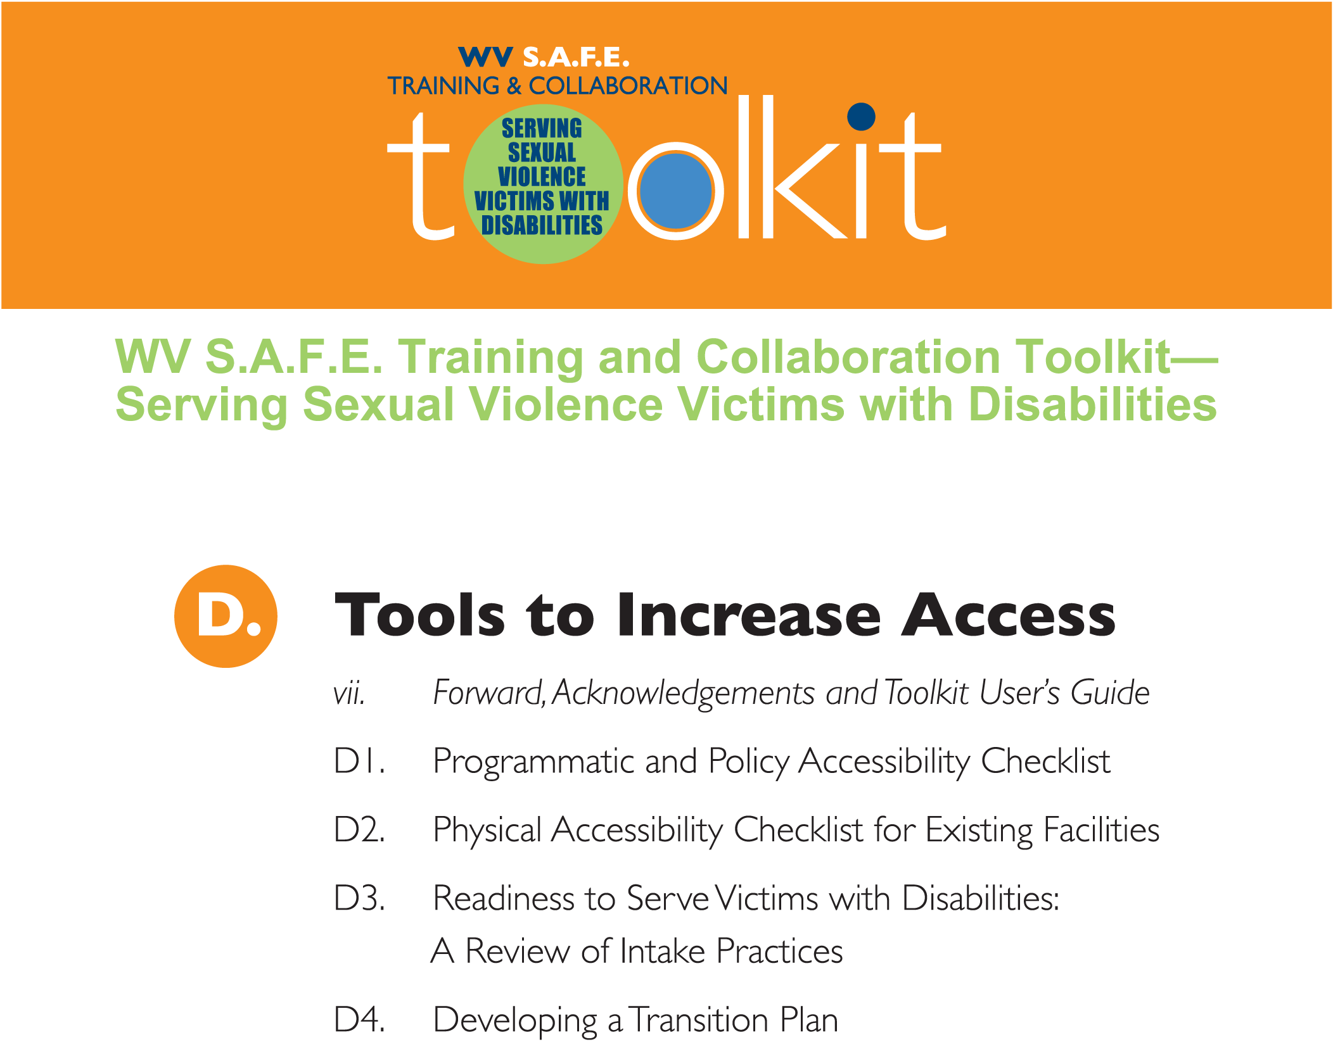

Forward
Service providers are finally recognizing the intersection of two issues: the prevalence of persons with disabilities who are sexually victimized and the prevalence of sexual violence victims who have disabilities. Although one in the same, the response to sexual violence victims who have disabilities may differ depending on their point of entry into the service delivery system. Sexual violence service providers have not been adequately trained in serving victims with disabilities. Disability service providers have not been trained in responding to sexual violence. There has been a lack of recognition that a coordinated community response is needed to ensure that the social service system (collectively comprised of the local, regional and state agencies that serve victims on the local level) effectively and equally meets the needs of these individuals. In West Virginia, through this project, we are bringing together service providers who aid sexual violence victims with those who serve persons with disabilities. Our goal is to increase the access victims with disabilities have to services. It is important to acknowledge that “getting to this place” did not happen overnight; rather, it required consciousness-raising and community organizing by dedicated activists. In essence, “getting to this place” is the story of two social movements—the anti-sexual violence movement and the disability rights movement—maturing into a “second wave” of activism and joining together to address needs of previously underserved populations.
The beginnings for both movements grew from the 1950s to the 1970s when minority groups—most notably African Americans, gays and lesbians, women and people with disabilities—began ardently fighting to secure their civil rights. Early in the women’s rights movement, women began to speak out about their personal experiences of sexual violence. In the decades to follow, tremendous progress was made toward supporting sexual violence victims. Rape crisis programs were established in counties throughout the United States to offer crisis intervention, support and advocacy for victims, as well as community awareness and prevention. A significant body of literature and research emerged that increased public concern about sexual violence. Legislative changes—including the enactment of state laws to ensure victim rights and federal laws such as the Rape Control Act in 1975 and the Violence Against Women Act of 1994—were enacted that have increased the efficacy of the criminal justice and medical community responses to sexual violence.1
Encouraged particularly by the civil rights and women’s rights movements, large-scale cross-disability rights activism began in the late 1960s with the goal of ending social oppression. That oppression kept children with disabilities out of the public schools and sanctioned discrimination against adults with disabilities in employment, housing and public accommodations. As part of this movement, the independent living movement emerged to support the choice of living in the community for people with even the most severe disabilities. The first independent living center opened in 1972; by the beginning of 2000, there were hundreds of such centers across the country and the world. In the meantime, a series of landmark court decisions and legislative changes—including the enactment of the Rehabilitation Act of 1973, the Individuals with Disabilities Education Act of 1975 and the Americans with Disabilities Act of 1990—secured for individuals with disabilities unprecedented access to their civil rights.2
These victories for the two movements, as critical as they were, have not ended sexual violence or discrimination against persons with disabilities.3 There is still a great need for continued activism. By coming together in localities across the country, as we are beginning to do in West Virginia, these movements are able to take the important next steps of educating one another and combining their resources to create positive systems change for sexual assault victims with disabilities. We hope you find the West Virginia S.A.F.E. Training and Collaboration Toolkit: Serving Sexual Violence Victims with Disabilities to be a useful resource to facilitate this cross-training and improve the response and partnerships across agencies and movements in your community.

Acknowledgements
The work of creating a toolkit involves the expertise and assistance of numerous individuals. The WV S.A.F.E. partnership is grateful to the individuals listed below for their contributions in the creation of this toolkit.

Project Partners and Primary Authors
Each of the three project partners coordinated the writing of the modules (in conjunction with the Project Consultant) within the sections pertinent to their disciplines. Each partner reviewed all of the modules during the development and pilot phases of the project. After each module was piloted and then reviewed and approved by the Office on Violence Against Women, the modules were then edited by the Toolkit Project Coordinator and Project Consultant.
Nancy Hoffman, State Coordinator, West Virginia Foundation for Rape Information and Services; Toolkit Project Coordinator
Jan Derry, Executive Director, Northern West Virginia Center for Independent Living
Chuck Thayer, Associate Director, Office of Community Health Systems and Health Promotion, West Virginia Department of Health and Human Resources
Kristin Littel, Project Consultant

Pilot Sites
Libby D’Auria, West Virginia Foundation for Rape Information and Services, Pilot Site Coordinator

Participating Pilot Site Agencies in Marion, Ohio and Preston Counties:
• Russell Nesbitt Services
• Sexual Assault Help Center
• Task Force on Domestic Violence, “HOPE”, Inc.
• Rape and Domestic Violence Information Center
• Northern West Virginia Center for Independent Living
• West Virginia Department of Health and Human Resources (Marion, Ohio and Preston counties)

Special thanks go to Amy Loder (Office on Violence Against Women); Michelle Wakeley, Nikki Godfrey, Betty Irvin, Whitney Boutelle, and Emma Wright (contributing authors); Susie Layne, Wade Samples, Marion Vessels, Mark Derry, Teresa Tarr and Suzanne Messenger (technical assistance with legal and policy components), West Virginia Foundation for Rape Information and Services staff and Kathy Littel (proofreading); Carol Grimes of Grimes Grafix (graphic designer) and to all of the survivors of sexual violence and women with disabilities who helped guide this work—both through this project and in creating the professional history of the individuals cited on this page. This toolkit is dedicated to ensuring that your shared experiences will help make for a better service delivery system for others.

WV S.A.F.E. Training and Collaboration Toolkit—Serving Sexual Violence Victims with Disabilities4
This toolkit offers guidance for service providers on working collaboratively to integrate accessible services for sexual violence victims with disabilities into the existing social service delivery system. The purpose is to provide the information and resources needed to begin the process of collaborating and cross-training among relevant agencies. Using the tools in the toolkit, agencies can build their capacity to offer responsive, accessible services to sexual violence victims with disabilities. The toolkit’s focus is on adult and adolescent victims with disabilities.
The concept for and contents of this toolkit evolved over a four-year period from the work of a project coordinated by several West Virginia statewide/regional agencies and piloted by local agencies from three counties. Although the toolkit is written for a West Virginia audience, other states and communities are welcome to adapt the materials to meet their needs.
This User’s Guide explains the toolkit’s features and organization as well as the pilot project.
Toolkit Features
The toolkit’s main feature is a collection of educational modules intended to:
• Facilitate dialogue and collaboration among partnering agencies to improve the accessibility and appropriateness of services across systems for sexual violence victims with disabilities (see the Collaboration 101 modules);
• Build individual providers’ knowledge related to fundamental issues in providing accessible and responsive services to sexual violence victims with disabilities (see Disabilities 101 and Sexual Violence 101 modules); and
• Provide tools to facilitate assessment and planning by individual agencies to improve the accessibility and appropriateness of their services for sexual violence victims with disabilities (see the Tools to Increase Access modules).
The toolkit was developed with the recognition that both individual and partnering agencies will adapt the toolkit materials to assist them in providing accessible and appropriate services to sexual violence victims with disabilities. NOTE:
• Individuals and agencies can use all of the modules and materials or select only the modules and materials that address their specific needs.
• Individuals and agencies can decide the sequencing of the modules that meets their needs, depending on factors such as the types of services each agency provides, who will be trained (designated or all staff, volunteers, students, board members), etc.
• Collaborative groups can decide the selection and sequencing of the modules to utilize based on the partnering service providers, strengths and gaps in the current response, level of existing collaboration among service agencies, issues that need to be addressed, etc.
• Individual agencies and partnerships may wish to add information and discussions on other pertinent issues not addressed through the modules.
Because the toolkit is available online, those using it can benefit from new material that may periodically be added. The toolkit can be accessed at http://www.fris.org/ to check for updates.
Background: Toolkit Development
In 2006, the West Virginia Foundation for Rape Information and Services (FRIS) received a grant from the U.S. Department of Justice, Office on Violence Against Women (OVW) to examine and implement changes to local and state systems that respond to women with disabilities and deaf women who are victims of sexual assault. Entitled West Virginia Sexual Assault Free Environment (WV S.A.F.E.), the resulting collaboration consists of three core team partner agencies: FRIS, the West Virginia Department of Health and Human Resources (DHHR) and the Northern West Virginia Center for Independent Living (NWVCIL).5
This collaborative’s broad mission is to identify and address state and local gaps and barriers in services and policies that impede the provision of effective, accessible and seamless services to survivors of sexual assault among women with disabilities and deaf women. The shared vision is:
“.. [C]reating permanent systems change at all levels of the sexual assault and disability systems and state policy in which effective services for women with disabilities and deaf women are fully integrated into the existing structure of victim services and advocacy.”
The statewide partnership, and subsequent participation of their counterparts in three counties (Marion, Ohio and Preston counties), conducted needs assessments and developed a strategic plan. The plan included the following short-term goals and objectives:
1. Foster collaboration among local service providers who interact with survivors with disabilities (to overcome fragmentation of services). Objectives: Coordinate and implement on-going partnership meetings and formalize collaborative processes among pilot site partners.
2. Build a sustainable common knowledge base among local service providers and among statewide partnering agencies. Objectives: Develop and implement a capacity building plan to strengthen the knowledge base and sustainable practices.
3. Ensure services and supports are accessible and responsive to the needs of women with disabilities and deaf women. Objectives: Assess accessibility with pilot site and state partners and implement prioritized components of accessibility transition plans.
The toolkit is the result of the sustainable cross-training component of this four-year project. Note that the materials are applicable to serving all adult/adolescent victims of sexual violence (recognizing the vast majority are women) and that the term “persons with disabilities” became inclusive of deaf persons, unless otherwise indicated.
Note also that while a limited number of agencies officially partnered in this pilot project, the benefit to victims can increase when the partnership is welcoming of any agency that might provide services to victims with disabilities. To that end, longer-term goals include: expanding local pilot site partnerships to include all points of entry into the service delivery system for victims with disabilities; improving the accessibility of those points of entry; providing ongoing capacity building opportunities; and replicating this systems-change model in additional counties in West Virginia.
Toolkit Organization
Toolkit Components. The toolkit offers a set of four separate components: A. Collaboration 101, B. Sexual Violence 101, C. Disabilities 101 and D. Tools to Increase Access. Each component is comprised of a series of informational modules.
Structure of the modules within each component. The individual modules within these components are primarily organized into two main sections: Core Knowledge and Discussion. Some modules include both sections while others include only the Core Knowledge or the Discussion section. Several of the Tools to Increase Access use a checklist, rather than a narrative format. All of the remaining modules include a cover page featuring a brief overview and the key points. Each also includes an introduction describing the purpose, objectives and any preparation needed.
• Core Knowledge: Depending on the content, the Core Knowledge section provides basic information on the topic. It may also include Test Your Knowledge questions to evaluate what was learned. These can be useful both for the reader and for supervisors who may choose to use the questions to gauge the knowledge of staff and volunteers.
The Core Knowledge section is intended for individual use—e.g., for self-paced learning, one-on-one training of employees such as agency orientation or continuing education, volunteer trainings, review prior to an agency or multi-agency discussion, etc.
• Discussion: The Discussion section is designed for use in a group setting, either within an agency or with outside partnerships. Each Discussion section indicates the estimated time frame for the dialogue and the preparation needed, if any; describes suggested activities and questions (targeted to create a common knowledge base, improve agency response and build collaboration); and ends with a closing assessment of what was learned during the discussion and changes providers/agencies plan to make as a result of the discussion.
• Resources: Some modules also include related forms and/or other sample materials.
The modules were developed to maximize agencies’ finite resources for in-house and multi-agency training. To that end, an effort was made to offer Core Knowledge sections that simplified complex topics as much as possible. It is a delicate balance to find a format in which the information provided can be easily understood but that provides enough detail to assist the reader in offering responsive assistance to victims with disabilities. As appropriate in each Core Knowledge and Discussion section, guided probes and case scenarios are included to assist service providers in applying the information to impact service delivery changes both within their own agencies and their communities.
Cross-referencing of modules. The modules were generally developed so they can be used independently of one another; however, a few make reference to other modules as prerequisites. Reference to other modules is also made throughout the modules so the reader can easily gain further knowledge on a particular topic.
Terminology used. Across all modules, the following should be noted:
• Agencies that interact with sexual violence victims and persons with disabilities typically refer to the individuals they serve as “clients,” “consumers” and/or “victims.” For convenience, “victims” and “clients” are primarily used.
• The terms “sexual violence” and “sexual assault” generally will be used to encompass sexual assault, sexual abuse and other forms of sexual violence.
• In recognition that the vast majority of victims of sexual violence are female and the vast majority of offenders are male,6 individual victims are often referred to using female pronouns and individual offenders are often referred to using male pronouns. This use of pronouns in no way implies that males are not victims of sexual violence or that females are not offenders; it is written in this format solely for the ease of reading the material.
Reproduction of materials. The non-commercial use and adaptation of these modules to increase knowledge about serving sexual violence victims with disabilities is permitted. Please credit any material used from this toolkit to the West Virginia Sexual Assault Free Environment (WV S.A.F.E.) project, a partnership of the West Virginia Foundation for Rape Information and Services, the Northern West Virginia Center for Independent Living and the West Virginia Department of Health and Human Resources (2010).

Funding was provided by Grant No. 2006-FW-AX-K001 awarded by the Office on Violence Against Women, U.S. Department of Justice. The opinions, findings, conclusions and recommendations expressed in this toolkit are those of the authors and do not necessarily reflect the views of the U.S. Department of Justice, Office on Violence Against Women.

Project partners welcome the non-commercial use of this toolkit to increase knowledge about serving sexual violence victims with disabilities in any community, and adaptation for use in other states and communities as needed, without the need for permission. We do request that any material used from this toolkit be credited to the West Virginia Sexual Assault Free Environment (WV S.A.F.E.) project, a partnership of the West Virginia Foundation for Rape Information and Services, the Northern West Virginia Center for Independent Living and the West Virginia Department of Health and Human Resources (2010). Questions about the project should be directed to the West Virginia Foundation for Rape Information and Services at www.fris.org.

1This paragraph was drawn primarily from California Coalition Against Sexual Assault, A vision to end sexual assault—The CALCASA strategic forum report (2001), as well as J. Meyers, History of sexual assault prevention efforts (Colorado Coalition Against Sexual Assault, 2000) and P. Poskins, History of the anti-rape movement in Illinois. All can be accessed through http://new.vawnet.org/category/index_pages.php ?category_id=576.
2This paragraph was drawn from University of California Berkley, Introduction: The disability rights and independent living movement (last updated 2010), through http://bancroft.berkeley.edu/collections/drilm/index.html.
3Adapted from University of California Berkley.
4Note that the format used in this User’s Guide was in part modeled after the Office for Victims of Crime’s Sexual assault advocate/counselor training, trainer’s manual (Office of Justice Programs, U.S. Department of Justice), https://www.ovcttac.gov/saact/index.cfm.
5An additional partner, the West Virginia University Center for Excellence in Disabilities, participated in the first two years of the project.
6Although males and females are both victimized by sexual violence, most reported and unreported cases are females (C. Rennison, Rape and sexual assault: Reporting to police and medical attention, 1992–2000 (Washington, DC: Bureau of Justice Statistics, Office of Justice Programs, U.S. Department of Justice, 2002), 1, http://bjs.ojp.usdoj.gov/index.cfm?ty=tp&tid=92; and P. Tjaden & N. Thoennes, Prevalence, incidence and consequences of violence against women: Findings from the National Violence Against Women Survey (Washington, DC: National Institute of Justice, Office of Justice Programs, U.S. Department of Justice, 1998), 2–4, http://www.ojp.usdoj.gov/nij/publications/welcome.htm. Regarding sex offenders, males make up the vast majority, but females also commit sexual crimes. In 1994, less than 1 percent of all incarcerated rape and sexual assault offenders were female (L. Greenfeld, Sex offenses and offenders: An analysis of data on rape and sexual assault, U.S. Department of Justice, Bureau of Justice Statistics (Washington, DC: 1997). As cited in R. Freeman-Longo, Myths and facts about sex offenders (Center for Sex Offender Management, 2000), http://www.csom.org/pubs.

